Spring Week-17 Assignment

Employee Management Rest Api application,

will be developing CRUD(Create,Read,Update and Delete) functionality along with

Sorting and some concepts of security.

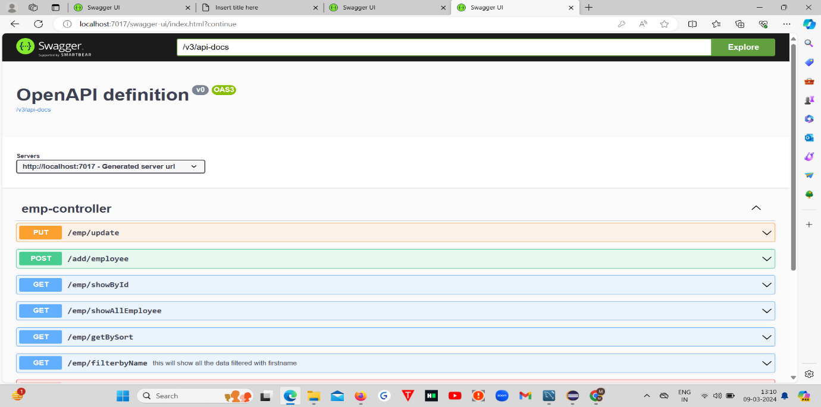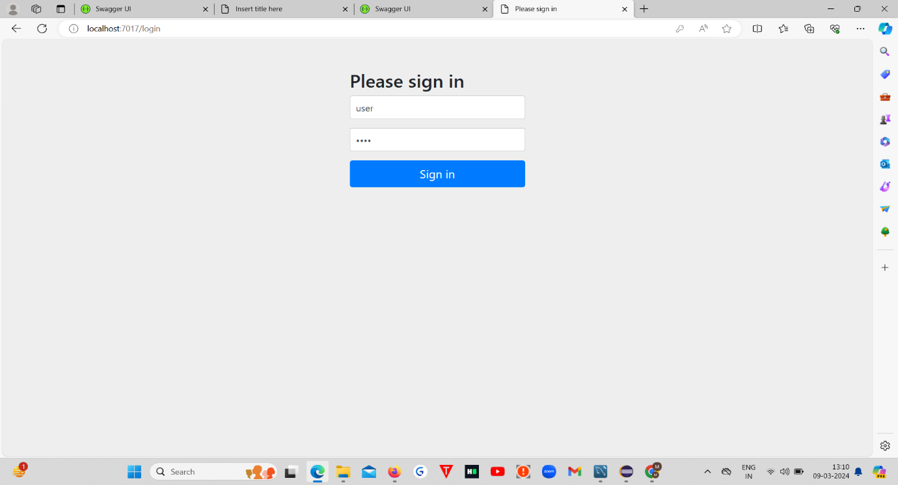1.Firstly I logged as user

User can view all employees and view employees by id

Other than that , user can’t add ,update delete

1.show All Employee

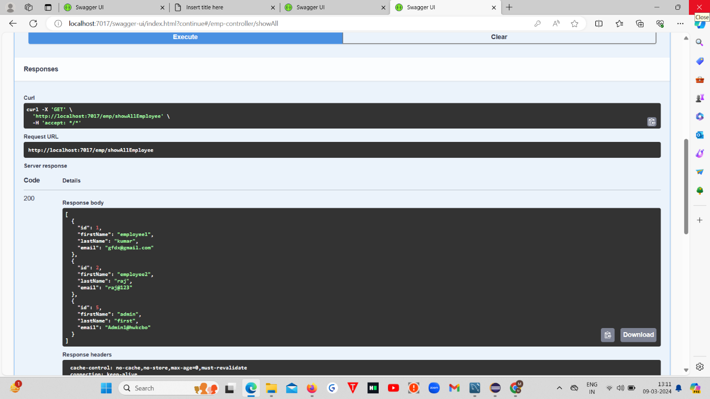

User Trying to add new Employee

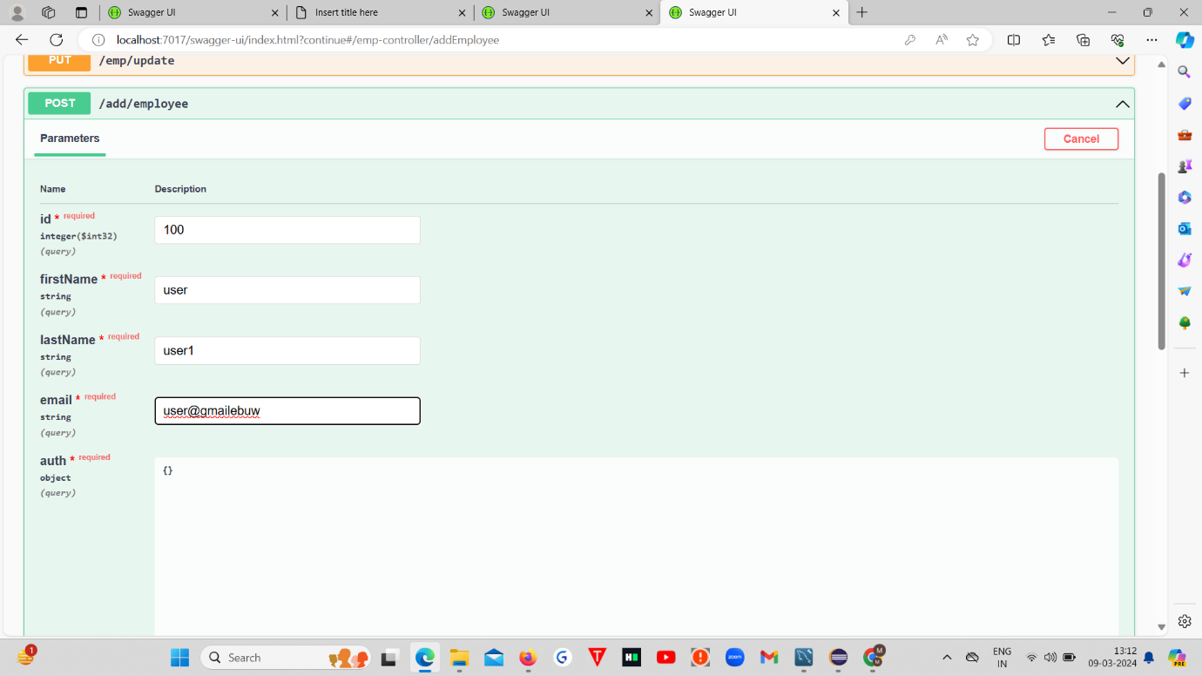

But see user can’t add an Employee

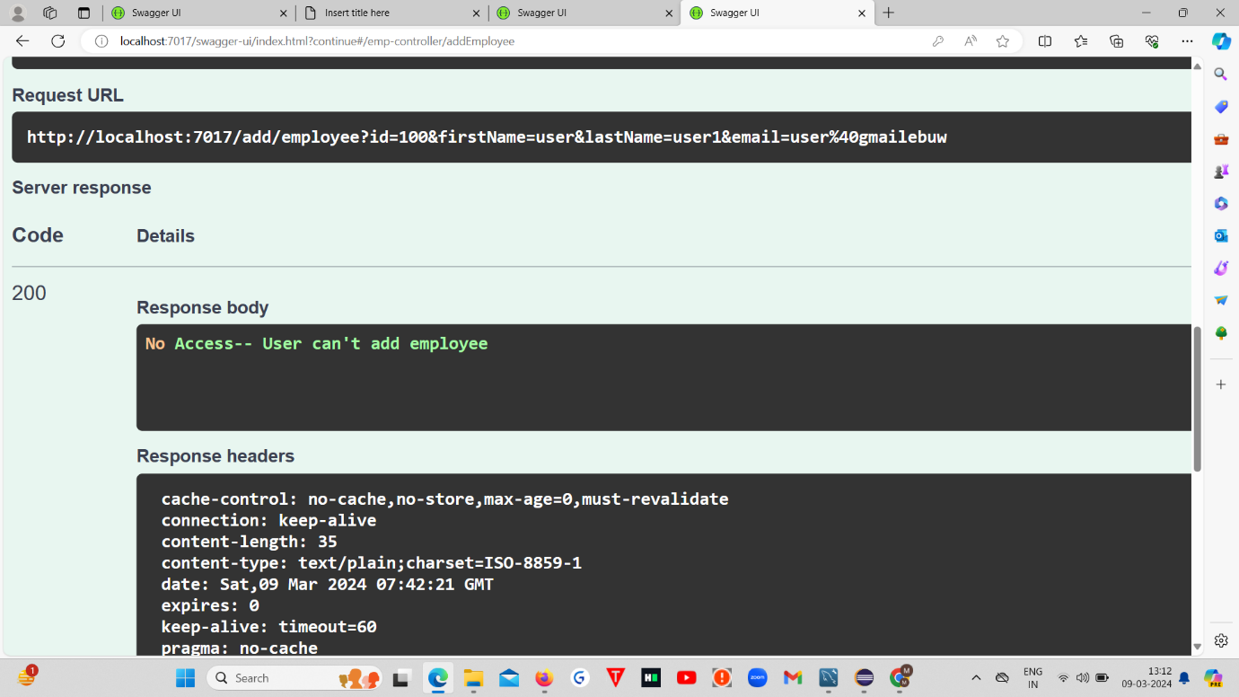

So user can only see the employees, uuser can’t do any actions.

Here,User trying to delete Employee----

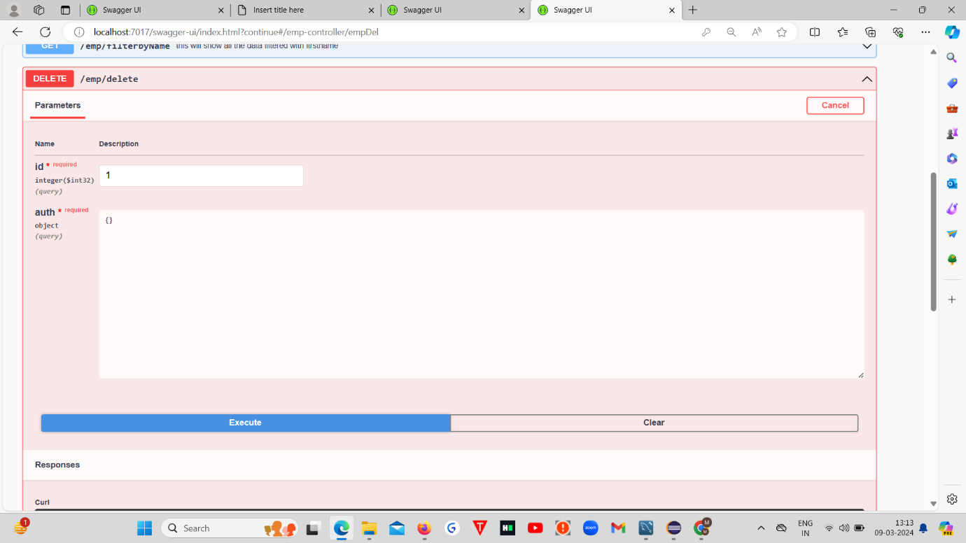

But see User can’t Delete the Employee—Response body throws an error by saying you can’t delete employee

“NO Access “

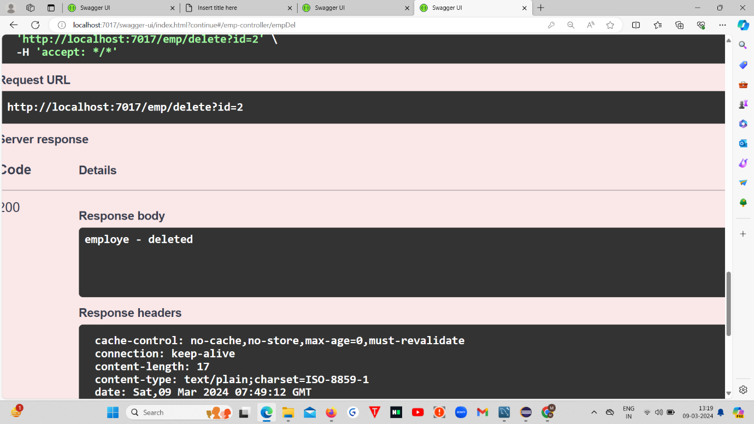

User accessing the show by id and user can able to see this

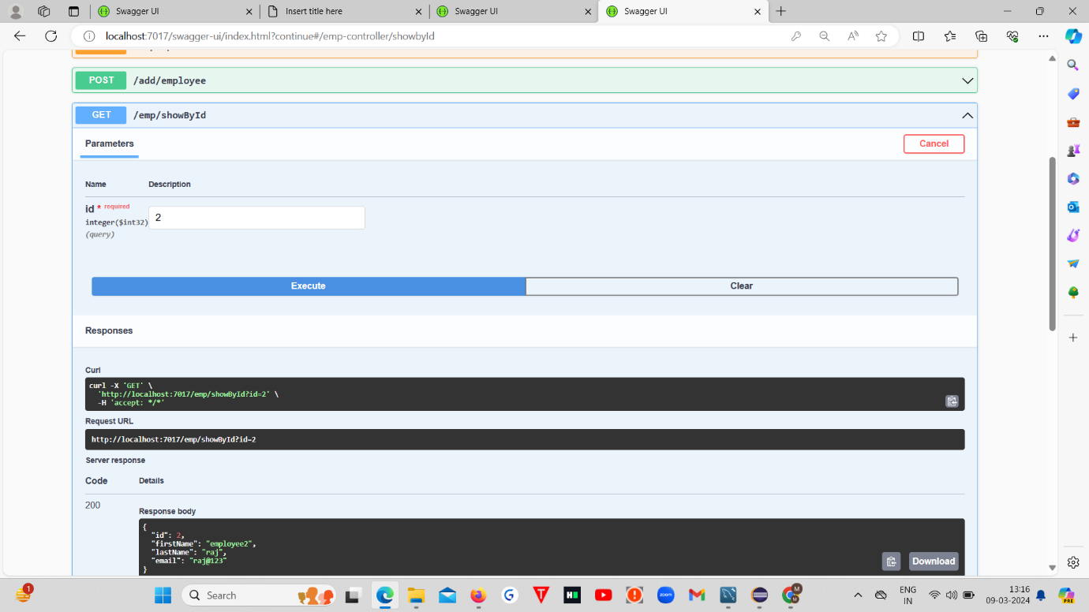

Now, I’m going to Login by Admin

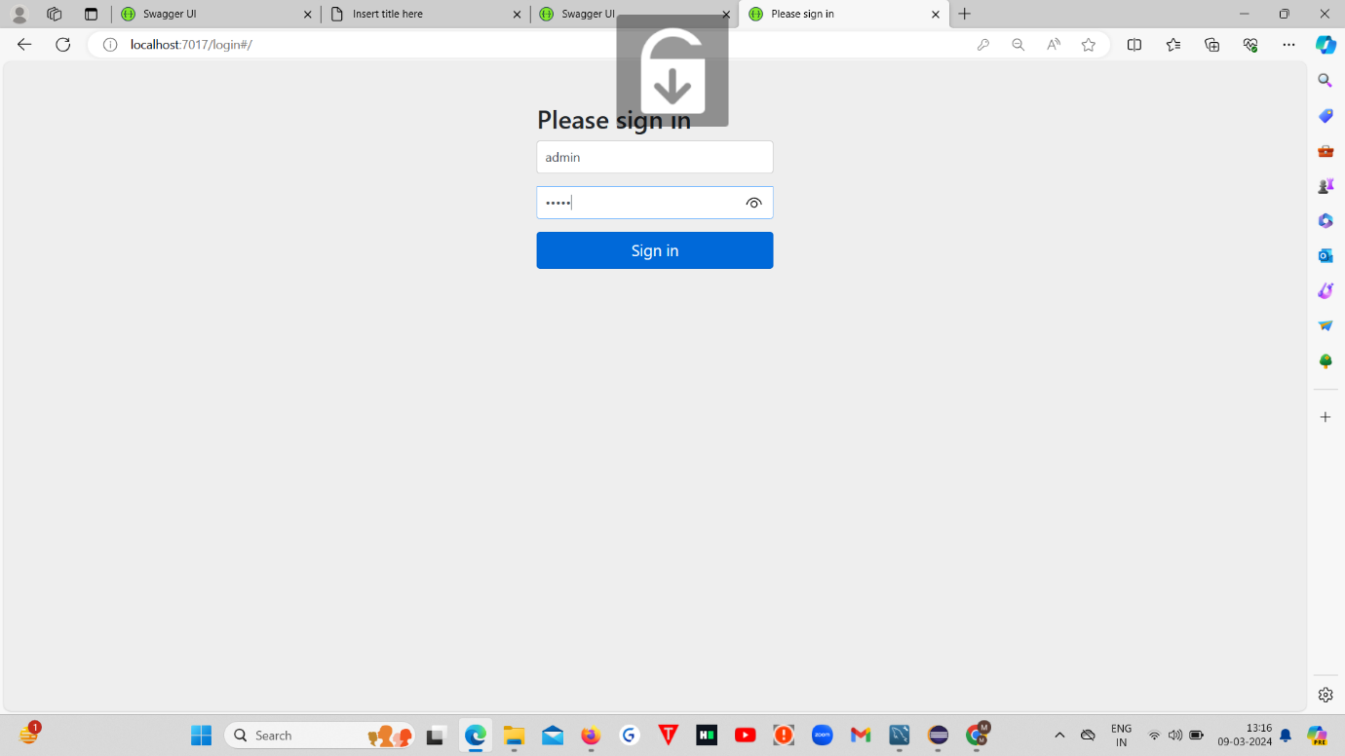

2. Admin trying to Add Employee

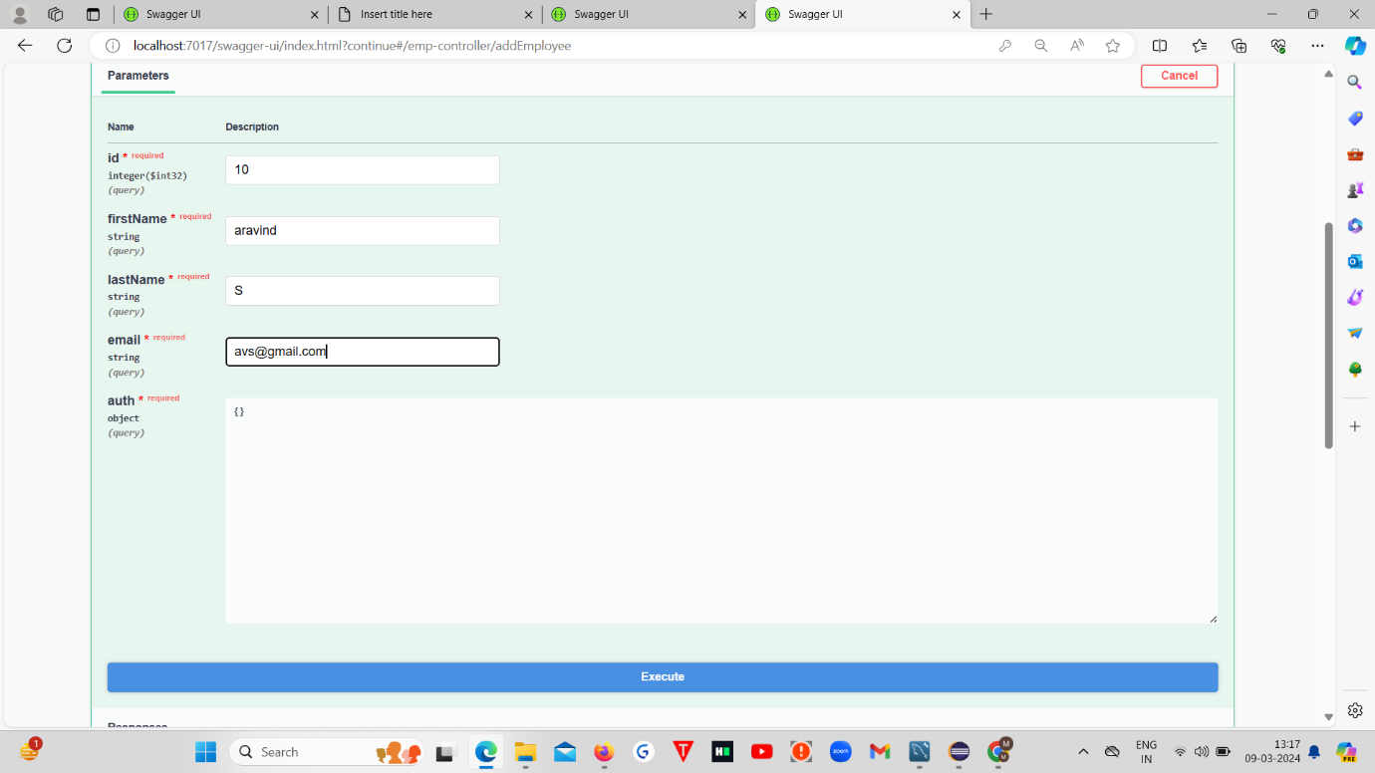

See Admin can Add the Employee

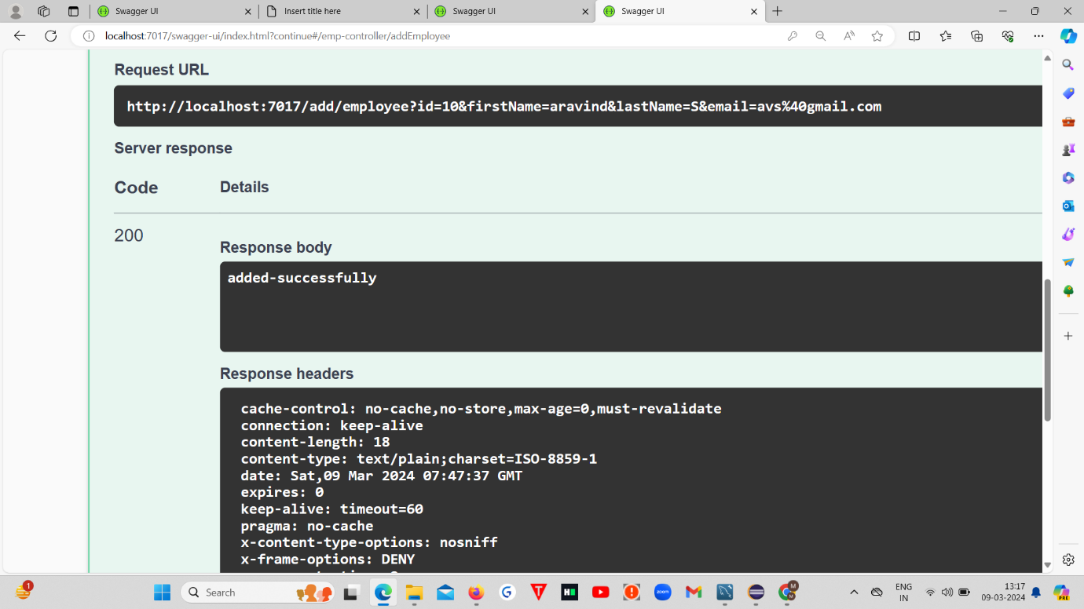

Admin can also Update,Delete and Do all the Actions

s